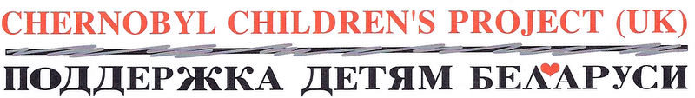
Name of Event or Action
…………….. is fundraising for Chernobyl Children’s Project (UK) by ……………….. The charity supports children and families in Belarus whose lives have been affected by the Chernobyl nuclear disaster.
Name | Address (to claim gift aid we need the full address and postcode of each sponsor – see declaration below) | Email address | Amount | Gift aid?

Gift Aid it! If you are a UK tax payer, we can reclaim 25p from the government for every £1 you donate. Please tick to confirm you would like your donation to be gift aided and provide your full address.

